**Creating a Serverless App using AWS**

* Search for the service “AWS Amplify”
* Click on Deploy – Get started

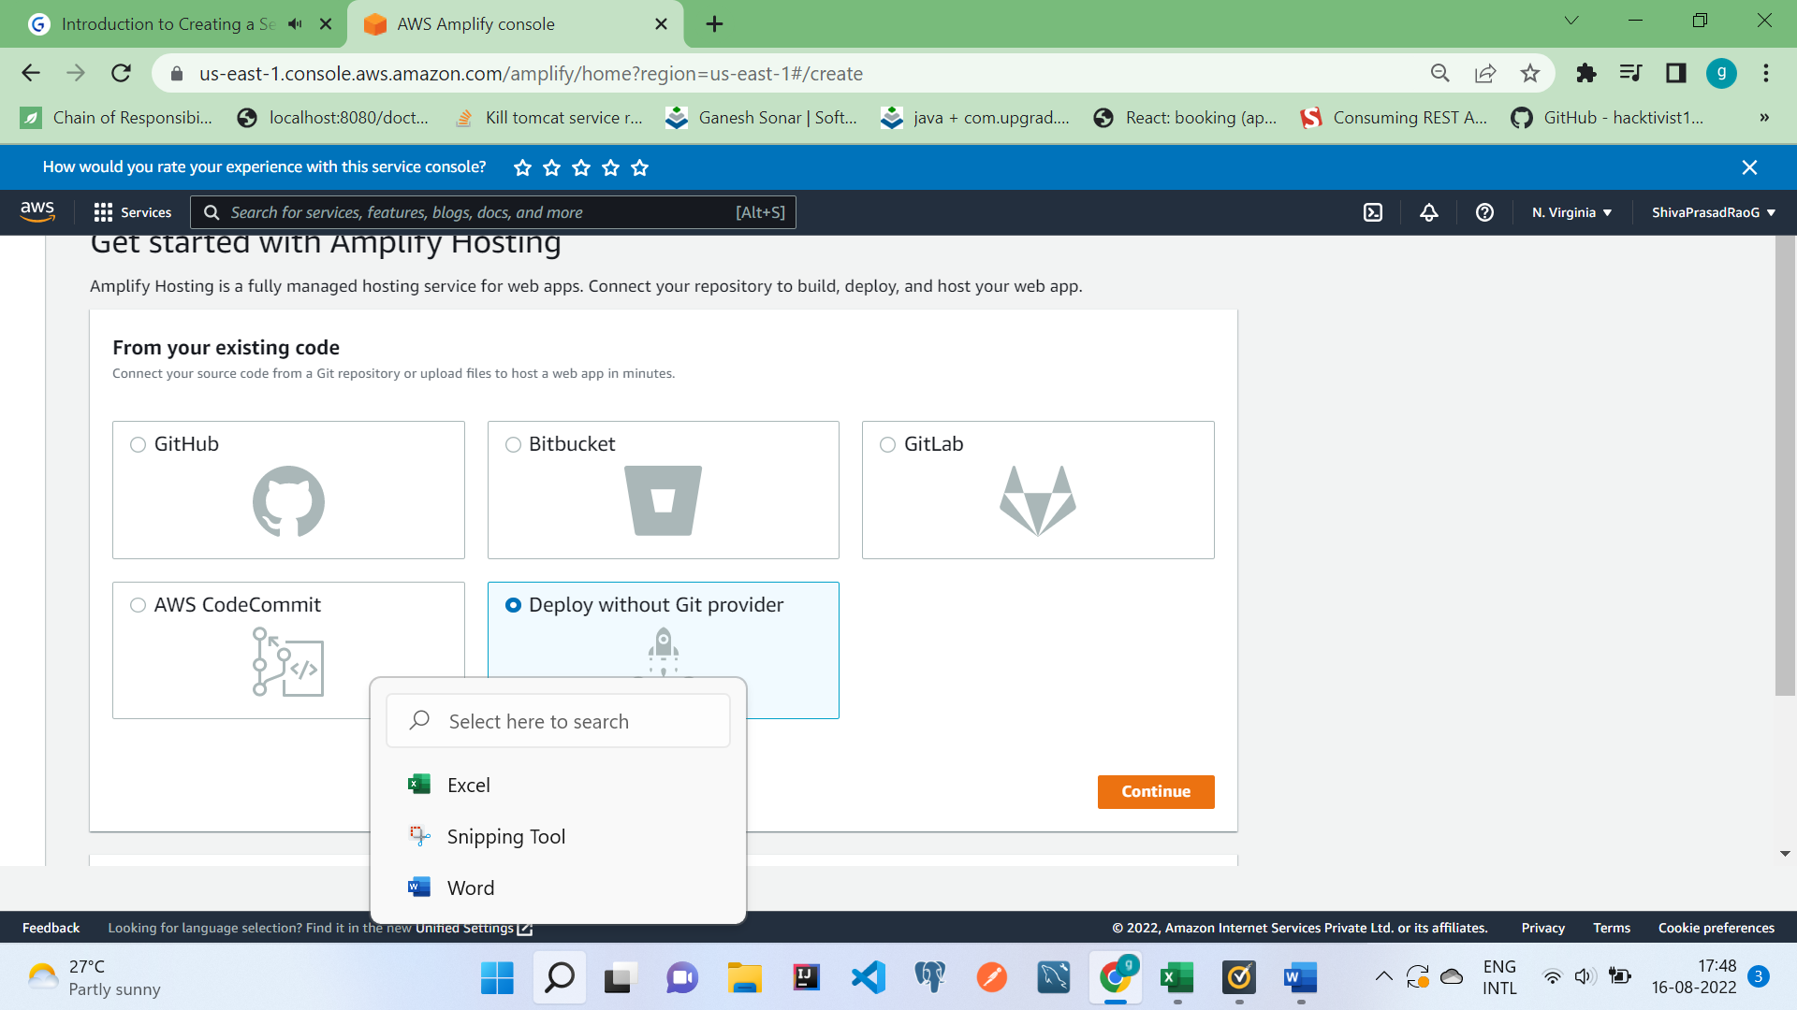

Compress the created folder in which the code is created and deploy and access the URL in the Domain

<https://dev.d1lkw0beg7me0u.amplifyapp.com/ServerlessApp/index.html>”

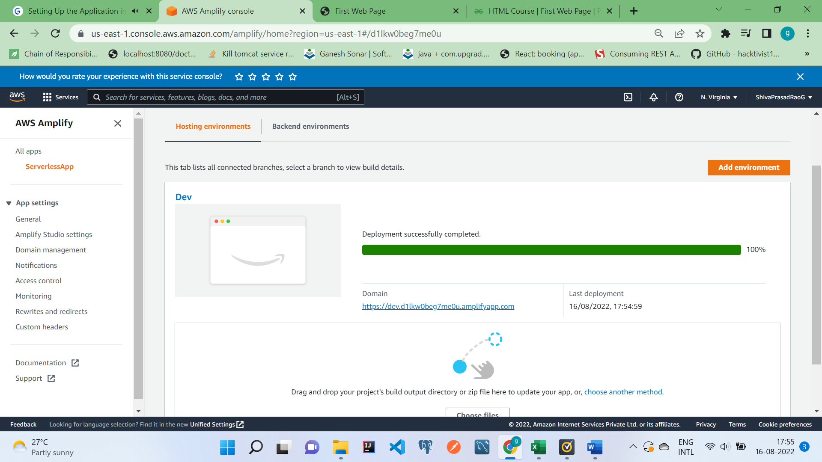

Compress the file and upload